Publish a new version of a function for beta testing without affecting users of the stable production version. Lambda creates a new version of your function each time that you publish the function.

**Note**

Lambda doesn't create a new version if the code in the unpublished version is the same as the previous published version. You need to deploy code changes in $LATEST before you can create a new version.

Steps to create :

**To create a new function version**

1. Open the [Functions page](https://console.aws.amazon.com/lambda/home#/functions) of the Lambda console.
2. Choose a function and then choose **Versions**.
3. On the version’s configuration page, choose **Publish new version**.
4. (Optional) Enter a version description.
5. Choose **Publish**.

Example: I have a Lambda function -> International-Bestseller-Books

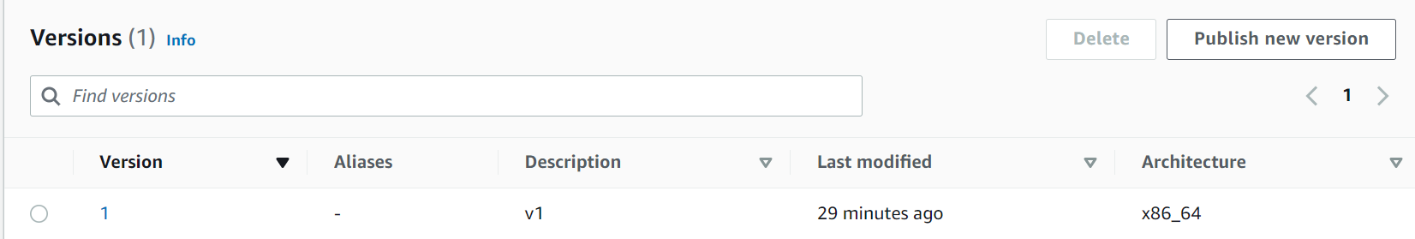

Now I have created a new version

The testing results are of **topbooks2020**

As you can see the results show the **top books of 2021**

